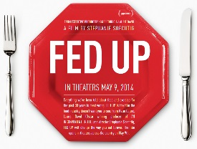**FED UP- Terms to understand and know**

Added Sugar- sugar/syrups added to foods and beverages during processing

Diet- restricting oneself to a special course of food

Processed Food- commercially prepared food designed for ease of consumption

Obesity- The condition of having excessive body fat

Diabetes- the body’s inability to produce enough insulin

Insulin- a protein hormone secreted in the pancreas, that controls and regulates the amount of sugar in the blood

Epidemic- a sudden, widespread occurrence of an undesirable condition

Lobbyist- a person who is part of a group of people seeking to influence politicians on a particular issue

Special Interest Group- a group of people seeking or receiving special advantages, often through political lobbying

Corporation- a company authorized to act as a single entity

Subsidy- a sum of money granted by the government to help a business maintain low prices

Federal Trade Commission(FTC) a federal agency that administers antitrust

and consumer protection legislation

McGovern Report- a report based in the proposition that people should eat less harmful foods rather than more foods

From the introduction, what do you expect to learn from the movie?

I expect to learn information about obesity and ways kids have been tricked to eat

more. Along with statistics with obesity and ways to combat obesity.

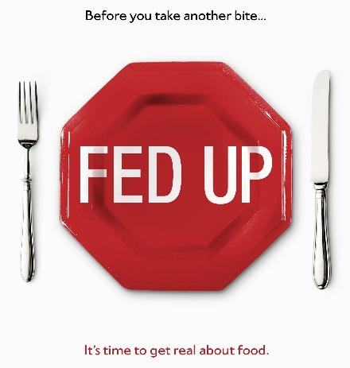Name: Quang Huynh Date: Class:

**Complete the following worksheet while watching, “Fed Up”**

1. **1 in 5 kids today is overweight.**
2. **More people die from being overweight than starvation.**

TRUE or FALSE

1. **How long would you have to bike to burn off one 20 oz. coke?** An hour and 15 min
2. **Why is a calorie not a calorie?** Almonds and coke are both 160 calories, but almonds are fiber, so no fat is gained. Coke goes to the liver and is turned into fat.
3. **How do food companies play a part in keeping people from the truth about foods?**

Food companies take half truths when discussing solutions and problems.



1. **Soda increases the risk of obesity by** 60%
2. **One soda increases your risk of diabetes by** 22%
3. **What are some obstacles to eating healthy?** The taste and price of food.
4. **When did the obesity epidemic begin?** 1977
5. **What did the McGovern report recommend that people do with their diets?** To cut down on fatty meats, saturated fats, cholesterol, and sugar.
6. **What happens to the taste of food when fat is removed?** The taste is dull, bland and nasty. Like cardboard.
7. **How do manufacturers compensate for the loss of fat in foods?** They add a bunch of sugar to mask the taste.
8. **What % of food in the grocery store contains added sugars?** 80%
9. **What is the most popular substance used to sweeten foods**? Sugar
10. **What are the effects of artificial sweeteners on your appetite?** Obesity, diabetes, heart disease, lipid problems, strokes, and cancer.
11. **What is the recommended daily allowance of sugar?** 6-9 teaspoons
12. **What is the typical teenager consumption of sugar per day?** 41 teaspoons
13. **How does sugar addiction compare to cocaine addiction?** There are sugar withdraws, and your brain lights up when sugar is consumed just like when cocaine is used. Sugar is 8 times more addictive than cocaine.
14. **What has changed about access to junk food since 30 years ago?** More sugar have been put into food for the past 30 years. Junk food has been dispersed everywhere now where they aren’t before, such as in gas stations, public spaces, and restaurants.
15. **What does the W.H.O. do?** The W.H.O. responsible for setting global health standards.
16. **What percent of calories should come from sugar?** 10%
17. **How did the food industry react to Michele Obama’s “Let’s Move” campaign**? The food industry was alert and reacted in terror, volunteering to help Michelle Obama.
18. **What did big food processors offer to do in response for her?** The big food processors offered to help through improving the nutrition of their foods.
19. **How does the US government make fighting obesity even harder in the marketplace?** The U.S. government provides subsidies to farmers to grow more corn to produce sweeteners. Furthermore, the government promoted cheese to the public as they had an abundance of cheese.
20. **When did the government start providing school lunches?** In 1946, The government started providing school lunches after World War II.
21. **In your opinion, should French fries be considered a vegetable?** In my opinion, French fries are not considered a vegetable. They are considered a snack food for me. Although they are made from potatoes and are technically a vegetable, they don’t fit my standards of a healthy vegetable.
22. **How do food marketers target children? Give some examples here from the ads you see.**

Food markets target children through their ads. There are fast food restaurant ads on the side of school buses, there are soft drink ads on chairs, and ads on television.

1. **What’s a “TOFI”?** Thin on the outside. fat on the inside.
2. **What is the most dangerous kind of fat to have?** The most dangerous kind of fat is belly fat.

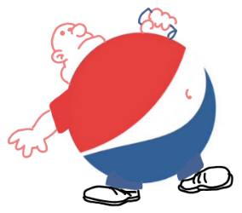

1. **30% of the US is obese. 40% of non-obese is TOFI. 51% of total US population is unhealthy.**
2. **What are some other countries doing to control obesity in kids?** In other countries and states, they’re offering more healthy options for food and removing foods that are high in sugar.
3. **What’s the single biggest change you can make at home to improve how you eat and lose weight?**

Evaluate your choices and determine which one is the better choice for your wellbeing and future. Limit sugars and fats in your food. You have to cook real food.

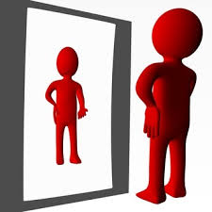

**REFLECTION: (Worth 7 points)**

Overall, how did this movie make you feel? What types of things did you learn that you agree with or do not agree with? How did this movie make you reevaluate your diet (or didn’t it?). These are a few questions to consider while writing your reflection below.

Overall, this movie made me feel weirded out. That people could ruin the wellbeing of the future for marketing purposes. Some of the things I learned I did not agree with, such as targeting children at a young age so they can get hooked onto eating unhealthy later, making the industry more money. Otherwise, some things said in the movie I agreed with, such as limiting sugar and fats in food to be more healthy, and other alternatives to lose weight. This movie did make me think about my diet but didn’t make me change it. I feel like I already have a good enough diet for myself, which isn’t hurting me internally or externally. I liked this movie, as it taught people about the hazards of food and the marketing that led to people making unhealthy choices.